EXPT NO: 9 | TRANSFORMER-BASED LLM CHATBOT USING STREAMLIT OR GRADIO
DATE: 02/11/2026 | TRANSFORMER-BASED LLM CHATBOT USING STREAMLIT OR GRADIO

PRE-LAB QUESTIONS (PROVIDE BRIEF ANSWERS TO THE FOLLOWING QUESTIONS)
Midhun P 24BAD069

- Explain the basic architecture of a Transformer-based LLM.

A Transformer-based LLM is a deep learning model designed to understand and generate human language.
It consists of multiple layers containing attention mechanisms and feed-forward neural networks.
The self-attention mechanism identifies relationships between different tokens in the input sequence.
Positional information helps the model understand the order of tokens in a sequence.
The model learns language patterns during training and uses them to generate meaningful responses.

- What is the role of tokenization in LLM response generation?

Tokenization is the process of converting text into smaller units called tokens.
These tokens may represent words, parts of words, or individual characters.
The tokenizer converts the input text into numerical token IDs that the model can process.
After processing, the model generates output token IDs that are decoded into readable text.
Tokenization helps the model process user queries and generate appropriate responses.

- Explain how a pre-trained LLM generates responses to user queries.

A pre-trained LLM has already learned language patterns from a large collection of training data.
When a user enters a query, the tokenizer converts the text into numerical tokens.
The model processes these tokens and predicts suitable output tokens based on the input context.
The generation process continues until the model reaches a stopping condition or the output limit.
Finally, the generated tokens are decoded into readable text and displayed to the user.

- Differentiate between Streamlit and Gradio.

Streamlit is a Python framework primarily used to develop interactive data applications and dashboards.
Gradio is designed to create simple interfaces for machine learning models and AI applications.
Streamlit provides components such as buttons, charts, forms, and data visualizations.
Gradio provides convenient components for text inputs, chatbot interfaces, images, and audio.
Both frameworks allow developers to build web interfaces using Python without extensive frontend coding.

- State the purpose of temperature and maximum output length in text generation.

Temperature controls the randomness of token selection during text generation.
A lower temperature generally produces more predictable and consistent responses.
A higher temperature can produce more varied and creative responses.
Maximum output length limits the number of new tokens generated by the model.
These parameters help control the response style, diversity, and length of generated text.

AIM
To develop an interactive chatbot using a pre-trained Transformer-based LLM and deploy it using Streamlit or Gradio.

SOFTWARE REQUIREMENTS
- Python
- TensorFlow / Keras / PyTorch
- Google Colab
- GitHub
- Hugging Face Transformers
- PyTorch
- Streamlit or Gradio

OBJECTIVES
Students will be able to:
- Understand the working of Transformer-based LLMs.
- Load and configure a pre-trained LLM.
- Generate responses using user prompts.
- Develop an interactive chatbot using Streamlit or Gradio.
- Test and deploy the application.

PROCEDURE
PART A: LOADING AND CONFIGURING A PRE-TRAINED LLM
Perform the following tasks:
- Select a suitable pre-trained LLM using Hugging Face Transformers.
- Load the model and its tokenizer.
- Prepare and tokenize sample user prompts.
- Generate responses by configuring suitable parameters, such as temperature and maximum output length.
- Display and examine the generated responses.

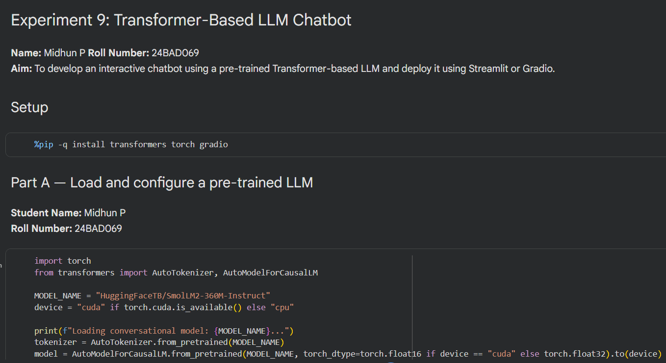
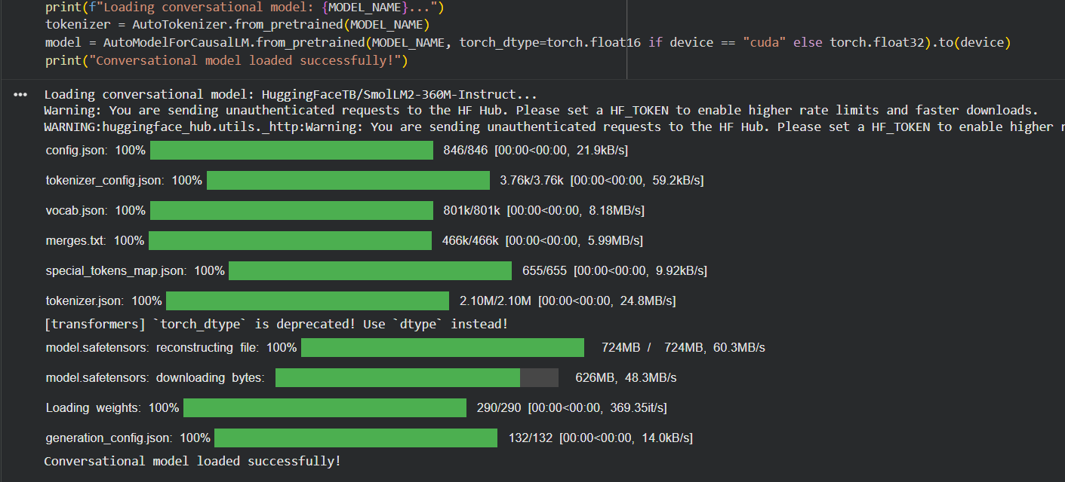
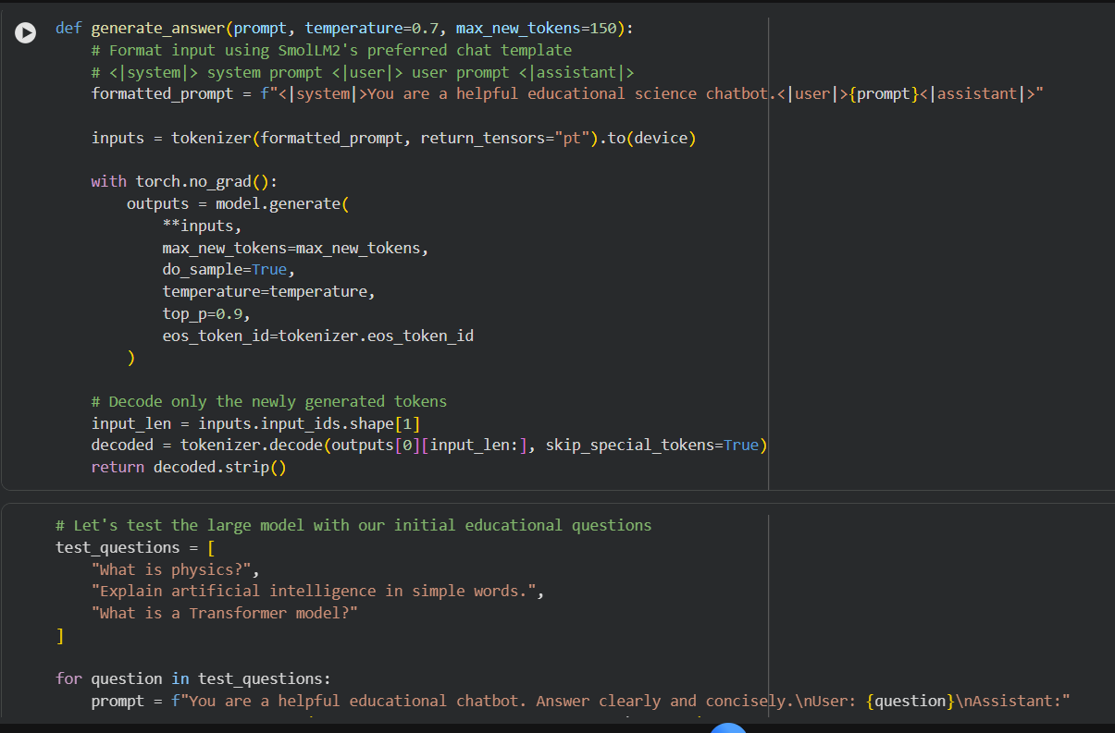
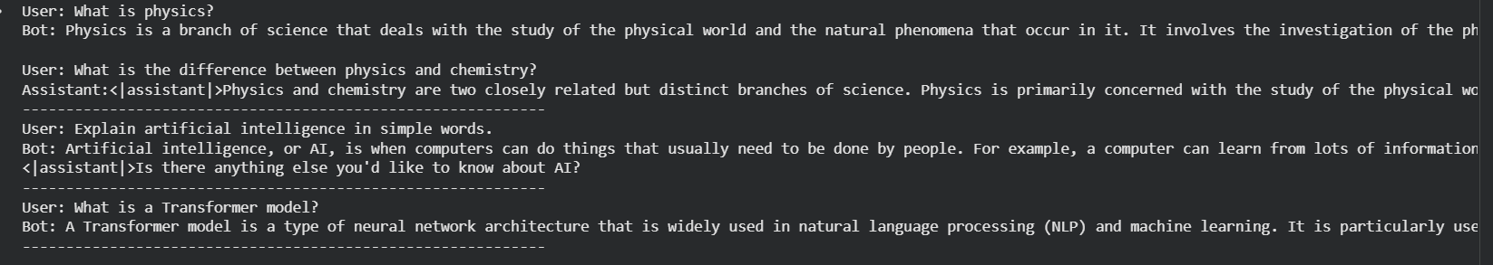

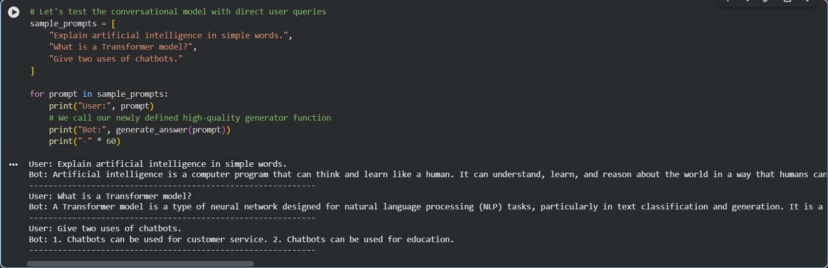

PART B: IMPLEMENTING CHATBOT FUNCTIONALITY

Perform the following tasks:
- Create a function to accept user queries and generate responses using the loaded LLM.
- Construct suitable prompts and display the generated responses.
- Maintain conversation history, if supported by the model.
- Test the chatbot with different queries and observe response quality.

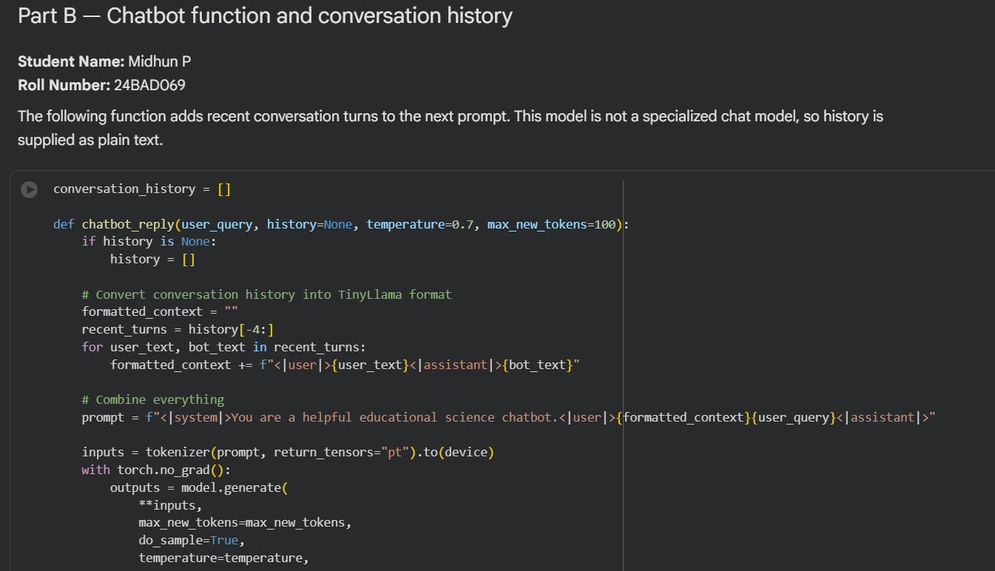
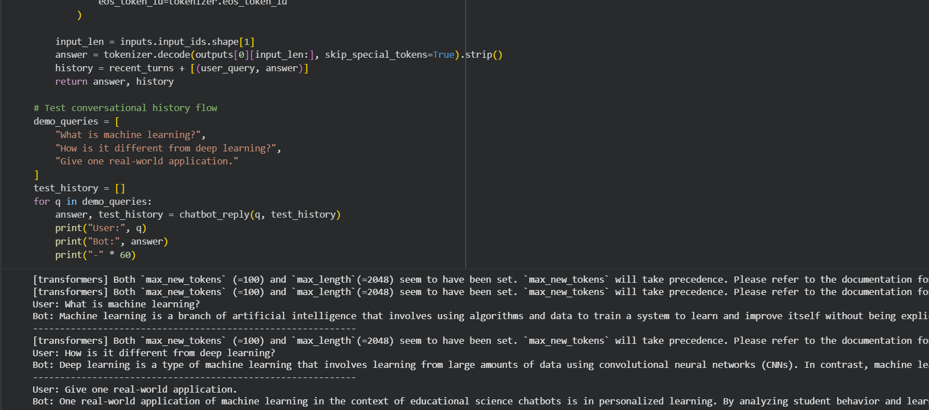
PART C: DEVELOPING AN INTERACTIVE INTERFACE

Perform the following tasks:
- Select Streamlit or Gradio to develop the chatbot interface.
- Create a text input component and a submission mechanism.
- Connect the interface to the LLM response-generation function.
- Display responses in a chat-style layout.
- Run and test the application with different user inputs.
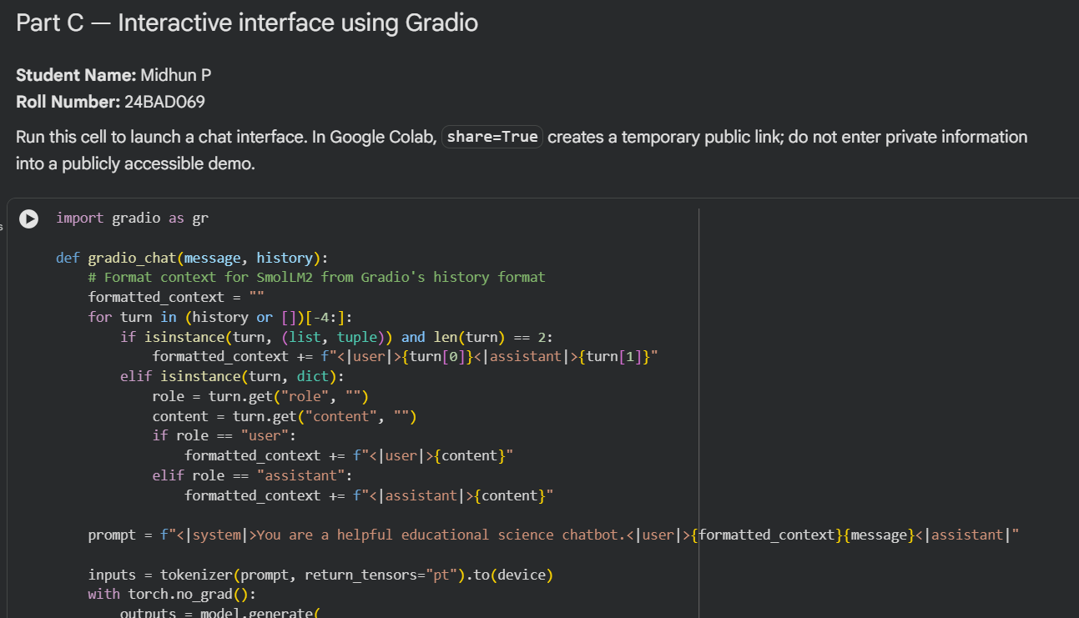
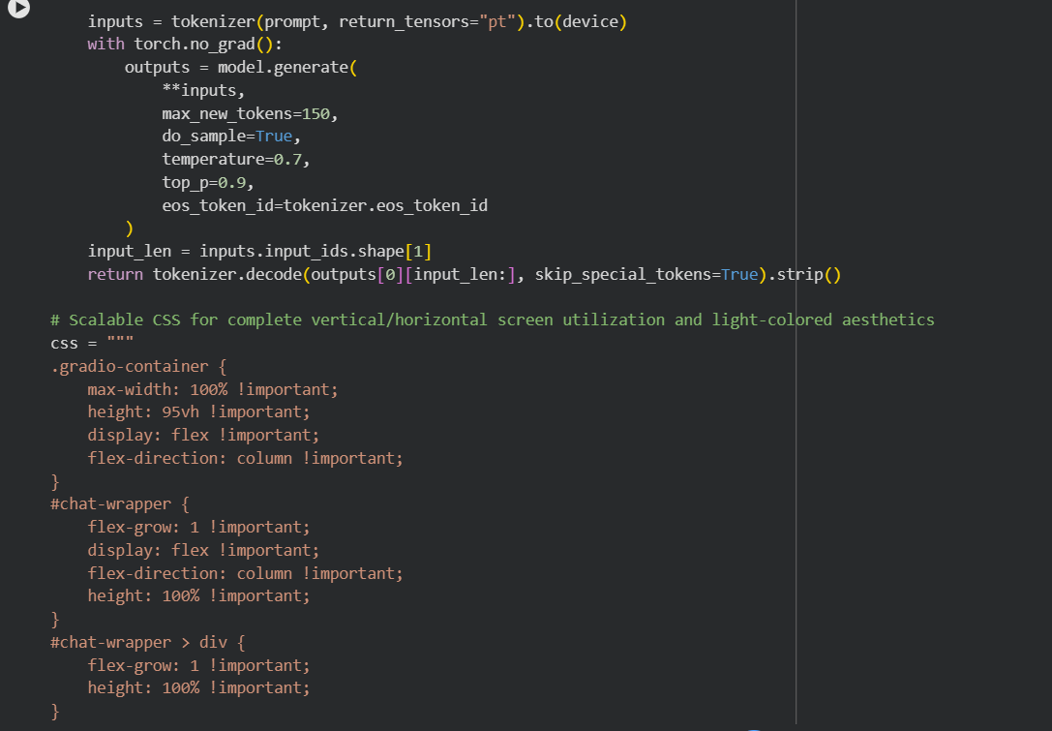
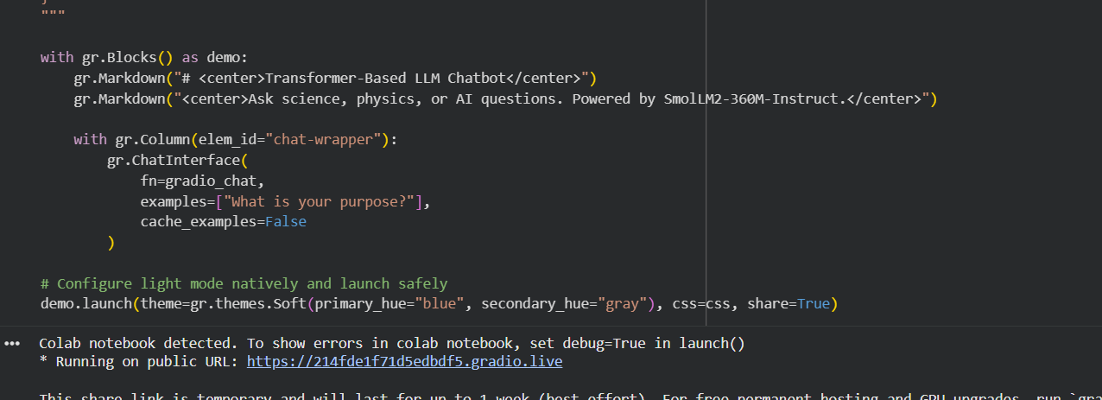
PART D: APPLICATION TESTING AND DEPLOYMENT

Perform the following tasks:
- Test the chatbot for response quality and usability.
- Observe limitations such as hallucinations and response latency.
- Organize the source code and create a requirements.txt file.
- Upload the project to GitHub.
- Deploy the application using a suitable platform, such as Hugging Face Spaces, if available.
- Document the results and limitations.
Demo Bot:
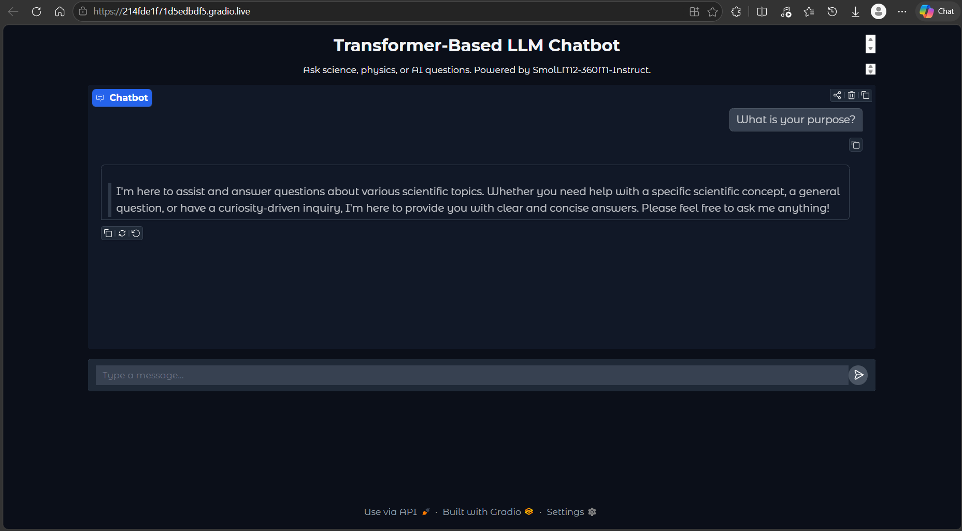

Deployed Bot:
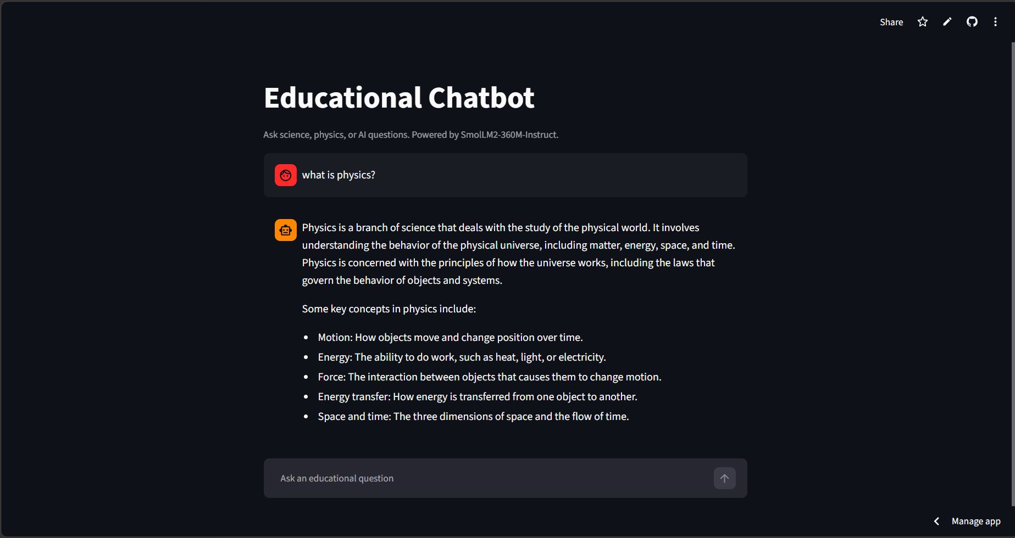

Results and Limitations
Results:
The Transformer-based chatbot was developed successfully using a pre-trained Large Language Model (LLM) and an interactive Gradio interface. The chatbot accepted text input from users, processed the queries using the language model, and generated responses in natural language. The interface provided a simple way for users to interact with the model without requiring direct interaction with the underlying code. The chatbot was tested with different types of questions to observe its response quality, relevance, and consistency.
The experiment demonstrated how a pre-trained Transformer model can be used to build a conversational application without training a language model from scratch. The model generated responses based on the input provided by the user. The chatbot could handle general questions and produce meaningful answers for many simple queries. The Gradio interface made the application more user-friendly by allowing users to enter questions and view the generated responses. The implementation also demonstrated the basic workflow of loading a pre-trained model, processing user input, generating text, and displaying the output through a web-based interface.
Limitations:
- Hallucinations: The chatbot sometimes generated incorrect, misleading, or fabricated information. These responses may sound convincing even when they are factually wrong. Therefore, the generated answers should be verified before being used for academic or important purposes.
- Response Latency: The time required to generate a response depended on the model size, hardware capabilities, and available computing resources. Responses could take longer when the model processed complex prompts or when computational resources were limited.
- Context Understanding: The chatbot did not always understand the complete meaning of a question or maintain the correct context throughout a conversation. Ambiguous questions, long conversations, or multiple related queries could result in irrelevant or inconsistent answers.
- Knowledge Limitations: The model's responses were based on patterns learned during training. It might not provide accurate information about recent events, specialized topics, or information not adequately represented in its training data.
- Computational Requirements: Loading and running Transformer models required sufficient memory and processing power. Limited hardware resources or restrictions in the deployment environment could affect performance and compatibility.
- Response Consistency: The chatbot could produce different answers to similar questions. The quality of the response also depended on how clearly the user framed the prompt.
Overall Observation:
The experiment demonstrated the practical implementation of a Transformer-based chatbot using a pre-trained language model and a Gradio interface. The chatbot was capable of generating natural-language responses and providing an interactive user experience. However, hallucinations, response latency, limited context understanding, and computational requirements affected its reliability. These limitations show that chatbot responses must be evaluated carefully and that further improvements, such as prompt optimization, response validation, and performance optimization, could improve the system's accuracy and usability.

POST-LAB QUESTIONS (PROVIDE BRIEF ANSWERS TO THE FOLLOWING QUESTIONS)

- Explain how an LLM generates responses from user prompts.

An LLM receives a user prompt as input and converts it into tokens using a tokenizer.
The token IDs are passed to the trained language model for processing.
The model uses its learned language patterns and the input context to predict the next tokens.
The predicted tokens are generated sequentially until a stopping condition is reached.
The output tokens are decoded into readable text and displayed as the chatbot's response.

- What is the importance of conversation history in a chatbot?

Conversation history stores previous user messages and chatbot responses.
It helps the chatbot understand the context of follow-up questions.
For example, a user can ask for more details about a topic discussed earlier.
Including previous exchanges in the prompt can make responses more relevant and coherent. However, the amount of history retained may be limited by the model's context window.

- Explain the effect of temperature on response generation.

Temperature controls the randomness involved in selecting output tokens.
A low temperature generally produces predictable and less varied responses.
A higher temperature allows more variation and may produce more creative answers.
Very high temperatures can make responses less consistent or relevant.
The appropriate temperature depends on whether accuracy, consistency, or creativity is preferred.

- Differentiate between local execution and cloud deployment.

Local execution runs the chatbot on the user's own computer.
It requires the necessary software, dependencies, and sufficient computing resources.
Cloud deployment runs the chatbot on a remote server accessible through the internet.
It allows users to access the application without installing the model on their own devices.
However, cloud deployment may require internet access and may involve hosting costs or resource limitations.

- State two limitations of LLM-based chatbots.

First, hallucinations: LLM chatbots may generate incorrect or misleading information while presenting it confidently.
Their responses are not guaranteed to be factually correct.
Second, response latency: Generating responses can take time, especially when using large models.
Limited computing resources and network delays may increase response time.
Therefore, chatbot responses should be evaluated for accuracy, reliability, and usability.

ASSESSMENT
Description | Max Marks | Marks Awarded
Pre Lab Exercise | 5
In Lab Exercise | 10
Post Lab Exercise | 5
Viva | 10
Total | 30
Faculty Signature

